Sprint 3 - Agility Design Document

April 18, 2022

Table of Contents

1. Executive Summary 3

1.1 Project Overview 3

1.2 Purpose and Scope of this Specification 3

2. Product/Service Description 3

2.1 Product Context 3

2.2 User Characteristics 3

2.3 Assumptions 3

2.4 Constraints 3

2.5 Dependencies 4

3. Requirements 4

3.1 Functional Requirements 5

3.2 Security 5

3.2.1 Protection 5

3.2.2 Authorization and Authentication 6

3.3 Portability 6

4. Requirements Confirmation/Stakeholder sign-off 6

5. System Design 6

5.1 Algorithm 6

5.2 System Flow 6

5.3 Software 6

5.4 Hardware 6

5.5 Test Plan 7

5.6 Task List/Gantt Chart 7

5.7 Staffing Plan 7

# Executive Summary

## Project Overview

Our robot should successfully travel around the rectangular course in room HH208. This is the accuracy course.

## Purpose and Scope of this Specification

In scope

* Responsibilities
* Meet times

Out of Scope

* Exact code needed for robot to complete the course
* Length of the time needed for the course

# Product/Service Description

In this section, describe the general factors that affect the product and its requirements. This section should contain background information, not state specific requirements (provide the reasons why certain specific requirements are later specified).

## Product Context

How does this product relate to other products? Is it independent and self-contained? Does it interface with a variety of related systems? Describe these relationships or use a diagram to show the major components of the larger system, interconnections, and external interfaces.

## User Characteristics

Create general customer profiles for each type of user who will be using the product. Profiles should include:

* Justin- Novice Python experience, never used Shepro robot prior, no experience using block code or javascript
* Briana – Never used Sphero Robot prior, no experience using block code or javascript
* Jason - Never used Sphero Robot prior, no experience using block code or javascript

## Assumptions

* Equipment availability, if robot isn’t available, we wouldn’t be able to test our code and see if our robot moved correct.
* Need an electronic device to connect to robot to start it and make it move.
* If robot isn’t charged, we won’t be able to use it.
* To make the robot move we need to have our code finished.

## Constraints

Describe any items that will constrain the design options, including

* Sphero may or may not have issues connecting to certain devices.
* Sphero may or may not roll correctly while on its path.
* Access to sphero is limited, there is only one sphero for three people.
* Sphero application may react/work differently depending on OS
* Limited knowledge of JavaScript
* Time constraints of physical meetings

## Dependencies

* The robot must be connected to a device via Bluetooth in order to function
* Said deice must be on and not have other devices connected to it.
* The robot will require to be charged before running the course.
* This robot needs a block code in order to run the course correctly.

# Requirements

* Robot must run the obstacle course
* Must start in the square
* Robot must avoid the 3 objects.
* Robot must go over ramp.
* Robot must knock over as many pins as possible.

## Functional Requirements

## Security

### Protection

* Sphero account is under 1 password.
* Meetings and dates the program is accessed are recorded

### Authorization and Authentication

1 password keeps data in a hoarded virtual vault

## Portability

The sphero.edu website/app has an open option to be shared with others, as well as a private option, connecting the robot to a device is simple, all it requires is a stable bluetooth connection, and how the robot moves/speaks/lights up is not affected by the OS differences.

# Requirements Confirmation/Stakeholder sign-off

Include documentation of the approval or confirmation of the requirements here. For example:

|  |  |  |
| --- | --- | --- |
| Meeting Date | Attendees (name and role) | Comments |
| 4/16 | Justin Briana Jason | Confirmed future meet ups and tasks to be done |
| 4/18 | Justin Briana Jason | Confirmed block code and robot completing obstacle |

# System Design

* We created an algorithm and made a flow chart
* Then did the block code for the robot to move around the obstacle

## Algorithm

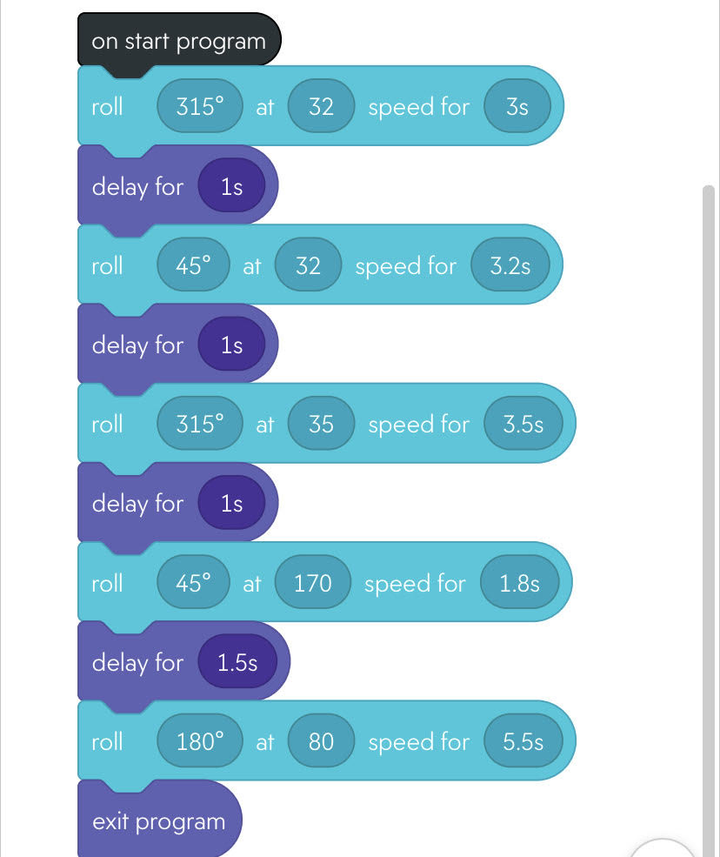

## System Flow

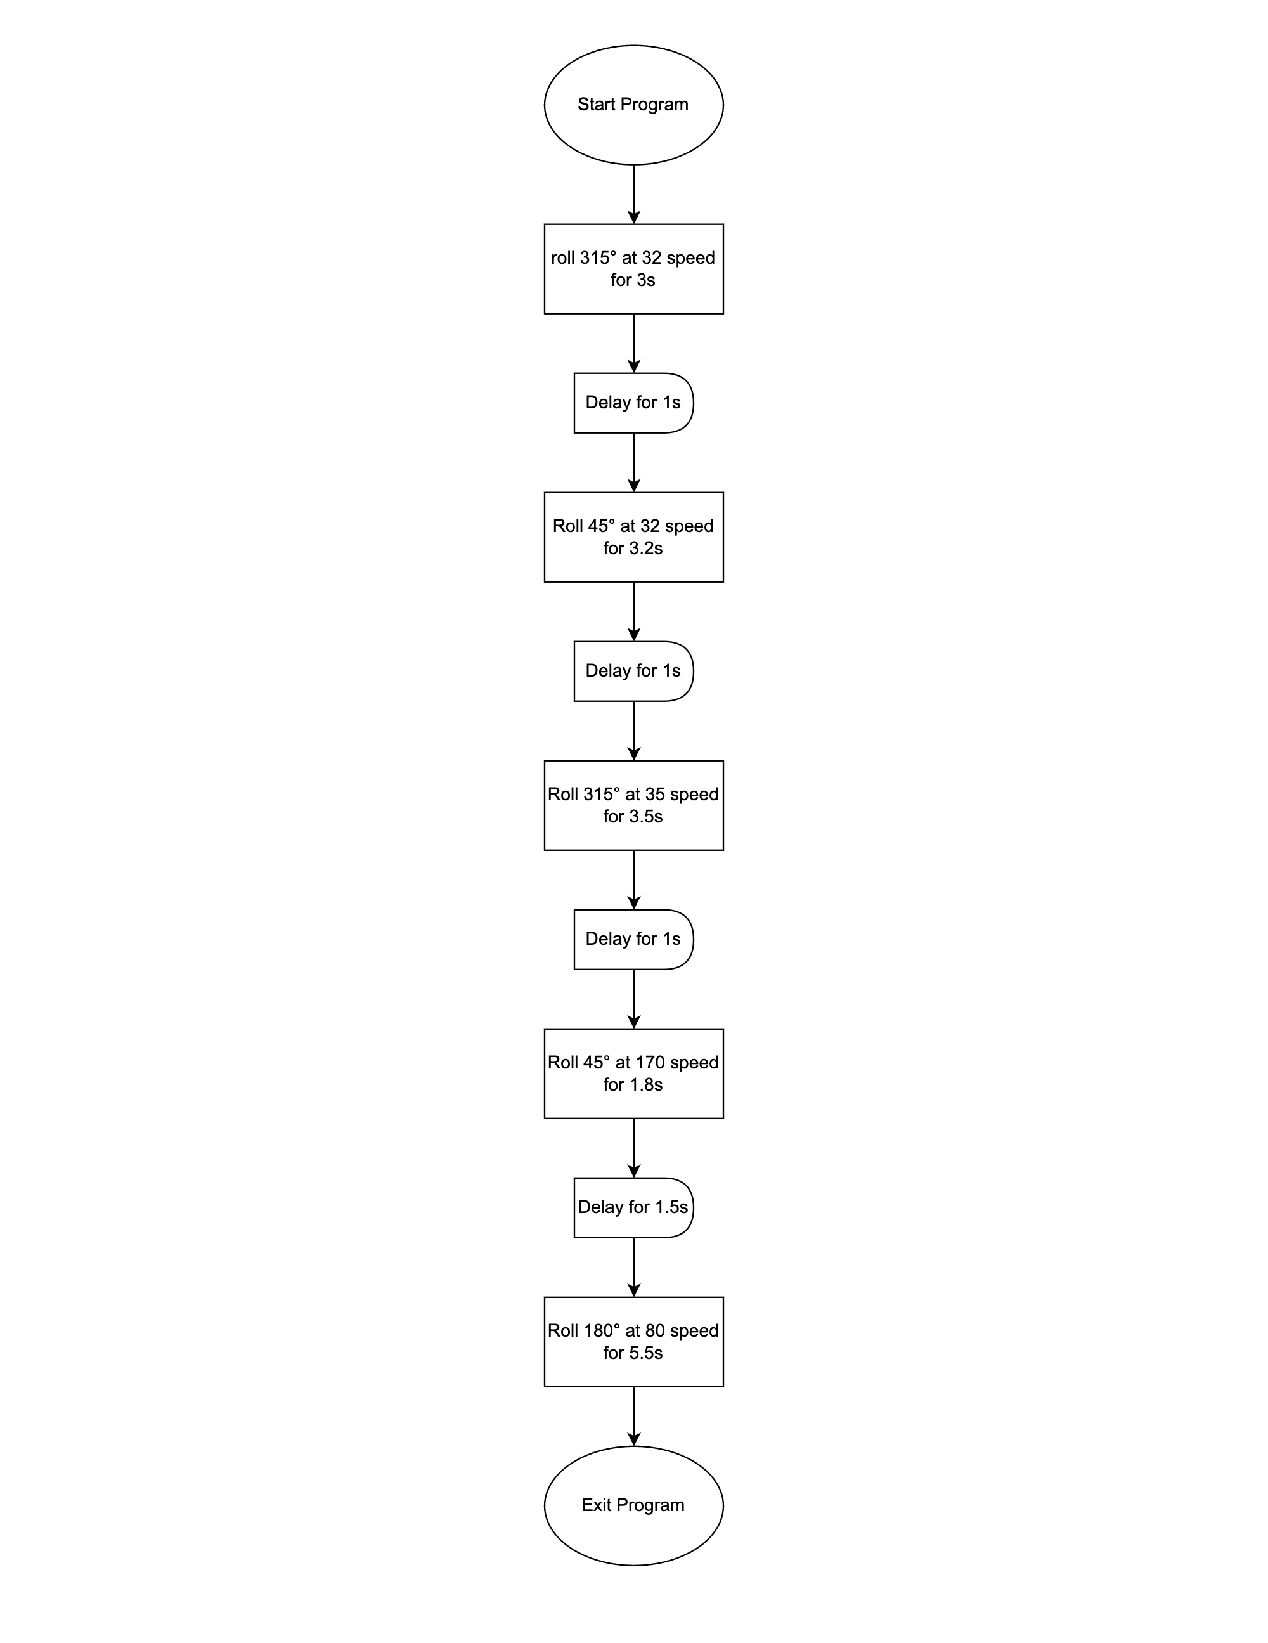

## Software

The sphero application follows block code/javascript

## Hardware

Cell phones and laptops were used to creat/ put together the block/ javascript code.

## Test Plan

Include a test plan showing all unit tests performed for this application, Include test rational, test date, staff member, pass/fail status

| **Reason for Test Case** | **Test Date** | **Expected Output** | **Observed Output** | **Staff Name** | **Pass/Fail** |
| --- | --- | --- | --- | --- | --- |
| Starting sprint 3 | 4/16 | Trying to get the robot to get over the ramp | Got it over the ramp | All | Pass |
| Complications | 4/16 | Try to get the robot to not hit the bottles | Missed all the bottles | All | Pass |
| Hitting the pins | 4/16 | Hit as many pins as we can | Hit three pins | All | Pass |
| Run everything through | 4/17 | Complete the full course | Completed and hit three pins | All | Pass |
|  |  |  |  |  |  |
|  |  |  |  |  |  |
|  |  |  |  |  |  |
|  |  |  |  |  |  |
|  |  |  |  |  |  |
|  |  |  |  |  |  |
|  |  |  |  |  |  |

## Task List/Gantt Chart

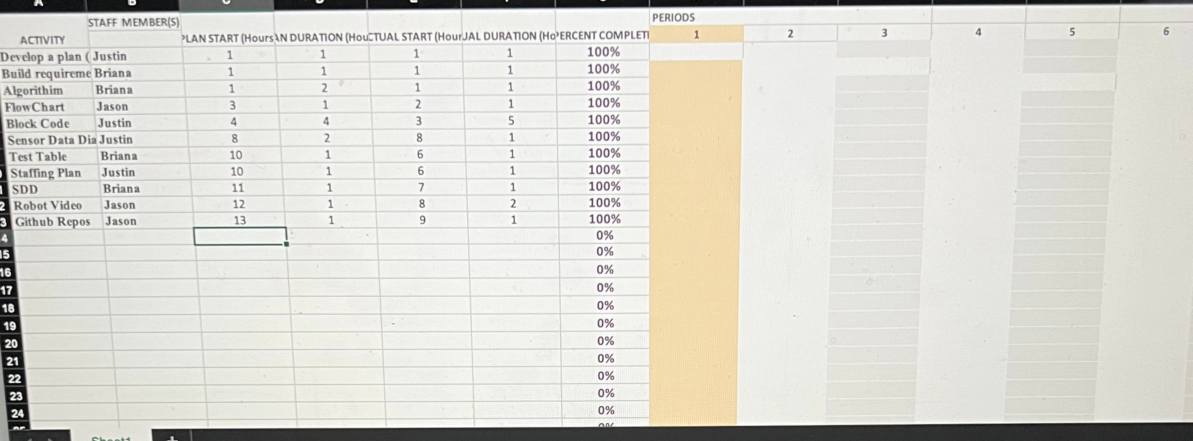

## Staffing Plan

Insert a chart/table that depicts the roles and responsibilities of each team member that worked on this project

| Name | Role | Responsibility | Reports To |
| --- | --- | --- | --- |
| Justin | Project manager | Manage roles and meet times | All |
| Briana | Doc. recorder | Documentation corrections  SDD completion | All |
| Jason | Visual | Creates workspace and GitHub repositories, works on SDD. | All |